U.S. FISH & WILDLIFE SERVICE

August 31, 2021

Western Monarch Butterfly Conservation Recommendations:

Purpose: Section 7(a)(1) of the Endangered Species Act of 1973 (ESA), directs federal agencies to use their authorities to further the purpose of the ESA, by conducting conservation programs for the benefit of endangered and threatened species. Conservation recommendations are discretionary activities that an action agency may undertake to avoid and minimize the adverse effects of a proposed action, implement recovery plans, or to develop information that is useful for the conservation of listed species. The purpose of the following conservation recommendations is to encourage federal agencies to incorporate monarch butterflies into their Environmental Assessments and Biological Assessments associated with Section 7 Biological Opinions, when in consultation with the U.S. Fish & Wildlife Service. These recommendations are organized by habitat zone, so that they may be cut/paste, as applicable and contingent upon project location. There is potential utility for these recommendations beyond Section 7, and they are intended to promote benefits for other pollinators as well.

Background: The western migratory monarch butterfly population has declined by more than 99 percent since the 1980s. An estimated 4.5 million monarchs overwintered on the California coast in the 1980s, whereas in 2020, the population estimate for overwintering monarchs was less than 2,000 butterflies. This extreme population decline is likely due to multiple stressors across the monarch’s range, including the loss and degradation of overwintering groves; pesticide use, particularly insecticides; loss of breeding and migratory habitat; climate change; parasites and disease. Historically, the majority of western monarchs spent the winter in forested groves near the coast from Mendocino County, California, south into northern Baja California, Mexico. In recent years, monarchs have not clustered in the southern-most or northern-most parts of their overwintering range, and there are year-round residents in some areas of the coast. This resident phenomenon is likely due to a combination of climate change and an abundance of residential-planted non-native, tropical milkweed that is available for monarchs year-round. Migratory western monarchs depart the overwintering groves in mid-winter to early-spring. Throughout the spring and summer, monarchs breed, lay their eggs on milkweed, and migrate across multiple generations within California and other states west of the Rocky Mountains. In an attempt to reverse the severe population decline of western monarch butterflies, and to protect other pollinators as well, we encourage implementation of the conservation recommendations listed below. Please see Figure 1 for suggested areas to focus voluntary conservation actions in California. Western monarch conservation actions outside of California are also important, especially for the larger pollinator community. Recommendations for other western states are addressed in the “All Breeding and Migratory Zones” section of this document.

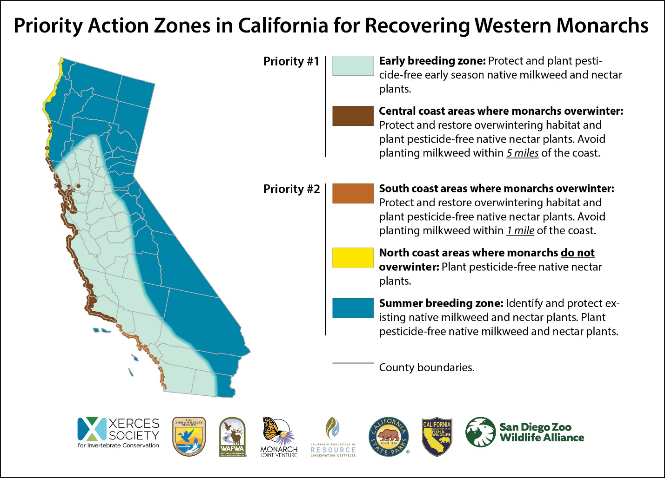
Figure 1. Priority Monarch Habitat Restoration Areas in California.

Coastal California Overwintering Habitat: Western monarchs migrate to the California coast, and cluster in a specific set of forested tree groves during the fall and winter each year. Overwintering groves provide protection from inclement weather, and possess suitable vegetation and microclimate conditions for monarchs (e.g., roosting trees, wind protection, dappled sunlight, nectar sources, water and/or dew for hydration, high humidity, and an absence of freezing temperatures). In the overwintering zone of the coast (i.e., within five miles of the coast from Mendocino County south through Santa Barbara County, and within one mile of the coast from Ventura County south through San Diego County), we recommend the following:
- Protect, manage, enhance and restore monarch butterfly overwintering groves (Find An Overwintering Site).
- Use only native, insecticide-free plants for habitat restoration and enhancement actions.
- Conduct overwintering grove habitat assessment(s), and develop and implement long-term grove management plans, as applicable. Management plan actions for groves may include, but are not limited to:
  - Enhance roosting trees within overwintering groves and within 1/2 mile of groves by planting trees (e.g., Monterey pine (Pinus radiata), Monterey cypress (Cupressus macrocarpa), Coast redwood (Sequoia sempervirens), coast live oak (Quercus agrifolia), Douglas fir (Pseudotsuga menzesii), Torrey pine (Pinus torreyana), western sycamore (Platanus racemosa), bishop pine (Pinus radiata) and others, as appropriate for location).

  - Avoid the removal of trees or shrubs within 1/2 mile of overwintering groves, except for specific grove management purposes, and/or for human health and safety concerns. The maintenance of trees and shrubs within a 1/2 mile of these sites provides a buffer to preserve the microclimate conditions of the winter habitat.

  - Conduct management activities (e.g., tree trimming, mowing, burning and grazing) in monarch overwintering groves from March 16-September 14 (outside of estimated timeframe when monarchs are likely present), in coordination with a monarch biologist.

  - Enhance nectar sources by planting fall/winter blooming forbs or shrubs within overwintering groves and within one mile of the groves (Nectar Planting Lists).

- Protect monarchs, other pollinators, and their habitats from pesticides (i.e., insecticides and herbicides). Specific recommendations may vary by site.

  - Avoid the use pesticides within one mile of overwintering groves, particularly when monarchs may be present. If pesticides are used, then conduct applications from March 16-September 14, when possible.

  - Screen all classes of pesticides for pollinator risk to avoid harmful applications, including biological pesticides such as Bacillus thuringiensis (UC Integrated Pest Management).

  - Avoid the use of neonicotinoids or other systemic insecticides, including coated seeds, any time of the year in monarch habitat due to their ecosystem persistence, systemic nature, and toxicity.

  - Consider non-chemical weed control techniques, when possible (Cal-IPC Non-chemical BMPs).

  - Avoid herbicide application on blooming flowers. Apply herbicides during young plant phases, when plants are more responsive to treatment, and when monarchs and other pollinators are less likely to be nectaring on the plants.

  - Whenever possible, use targeted application herbicide methods, avoid large-scale broadcast applications, and take precautions to limit off-site movement of herbicides (e.g., drift from wind and discharge from surface water flows).

  - Separate habitat areas from areas receiving chemical treatments with a pesticide-free spatial buffer and/or evergreen vegetative buffer of coniferous, non-flowering trees to capture chemical drift. The appropriate monarch and pollinator habitat spatial buffer size depends on several factors, including weather and wind conditions, but at a minimum, the habitat should be at least 40 feet from ground-based pesticide applications, 60 feet from air-blast sprayers, and 125 feet from any systemic insecticide applications or seed-treated plants.

- To minimize the spread of the pathogen Ophryocystis elektroscirrha (OE), and to encourage natural monarch migration, do not plant non-native tropical milkweed (Asclepias curassavica). OE is able to build up on tropical milkweed, because these plants are evergreen, and they do not die back in the winter. OE can be debilitating and/or lethal to monarchs.

- Remove tropical milkweed that is detected, and replace it with nectar plants suitable for the location (Nectar Planting Lists).

- To assist in maintaining normal migration behavior, do not plant any type of milkweed within five miles of the coast from Mendocino County south through Santa Barbara County, and within one mile of the coast south of Santa Barbara County.

- After appropriate training, conduct grove monitoring for butterflies during the Western Monarch Counts each fall and winter. When possible, report when monarchs arrive and depart the groves each year (Western Monarch Count).

- To provide benefits for monarchs and other pollinators anywhere on the landscape within the overwintering zone, install a mosaic of nectar plants that bloom throughout the year, as is feasible (Nectar Planting Lists).

Breeding and Migratory Habitat: Monarch butterflies breed and migrate across multiple generations each year throughout the western U.S. The early breeding zone (i.e., Priority 1) is an estimated area in California where monarchs are likely to breed and/or lay their eggs on milkweed after departing the overwintering groves in mid-winter to early spring each year (See Figure 1, above). Early emerging milkweed species are likely a limiting factor on the landscape in the early breeding zone and may be associated with the severe population decline of western monarchs, and these plants are essential to successfully create the next generation of migratory butterflies. For monarch breeding and migratory habitat, we recommend the following:
Priority 1 Zone:
- Enhance and maintain habitat in the Priority 1 early breeding zone of California, (Figure 1, above), by identifying and protecting existing habitat, and planting native, insecticide-free early-emerging milkweed species (e.g., Asclepias vestita, A. californica, A. eriocarpa, A. cordifolia, A. erosa), and flowering plants that are available to monarchs from January-April, as appropriate for the project location (Nectar Planting Lists; Milkweed Seed Finder).

For All Breeding and Migratory Zones:

- Use only native, insecticide-free plants for habitat restoration and enhancement actions.

- Enhance and maintain habitat in the Priority 2 zone of California (Figure 1, above) and in other western States, by identifying and protecting existing habitat, and planting milkweed species and flowering plants that are appropriate for the location (Nectar Planting Lists; Milkweed Seed Finder).

- Conduct management activities such as mowing, burning and grazing in monarch breeding and migratory habitat outside of the estimated timeframe when monarchs are likely present (Figure 2, Recommended Management Timing Map, below).

- Protect monarchs, other pollinators, and their habitats from pesticides (i.e., insecticides and herbicides).

  - Avoid the use of pesticides when monarchs may be present, when feasible (Figure 2, Recommended Management Timing Map, below).

  - Screen all classes of pesticides for pollinator risk to avoid harmful applications, including biological pesticides such as Bacillus thuringiensis (UC Integrated Pest Management).

  - Avoid the use of neonicotinoids or other systemic insecticides, including coated seeds, any time of the year in monarch habitat due to their ecosystem persistence, systemic nature, and toxicity.

  - Consider non-chemical weed control techniques, when feasible (Cal-IPC Non-chemical BMPs).

  - Avoid herbicide application on blooming flowers. Apply herbicides during young plant phases, when plants are more responsive to treatment, and when monarchs and other pollinators are less likely to be nectaring on the plants.

  - Whenever possible, use targeted application herbicide methods, avoid large-scale broadcast applications, and take precautions to limit off-site movement of herbicides (e.g., drift from wind and discharge from surface water flows).

  - Separate habitat areas from areas receiving treatment with a pesticide-free spatial buffer and/or evergreen vegetative buffer of coniferous, non-flowering trees to capture chemical drift. The appropriate monarch and pollinator habitat spatial buffer size depends on several factors, including weather and wind conditions, but at a minimum, the habitat should be at least 40 feet from ground-based pesticide applications, 60 feet from air-blast sprayers, and 125 feet from any systemic insecticide applications or seed-treated plants.

- To minimize the spread of the pathogen Ophryocystis elektroscirrha (OE), do not plant non-native tropical milkweed (Asclepias curassavica). OE can build up on tropical milkweed and infect monarchs, because these plants are evergreen and do not die back in the winter. OE can be lethal to monarchs.

- Remove tropical milkweed that is detected, and replace it with milkweed and nectar plants appropriate for the location (Nectar Planting Lists; Milkweed Seed Finder).

- Report milkweed and monarch observations from all life stages, including breeding butterflies, to the Monarch Milkweed Mapper or via the project portal in the iNaturalist smartphone app.
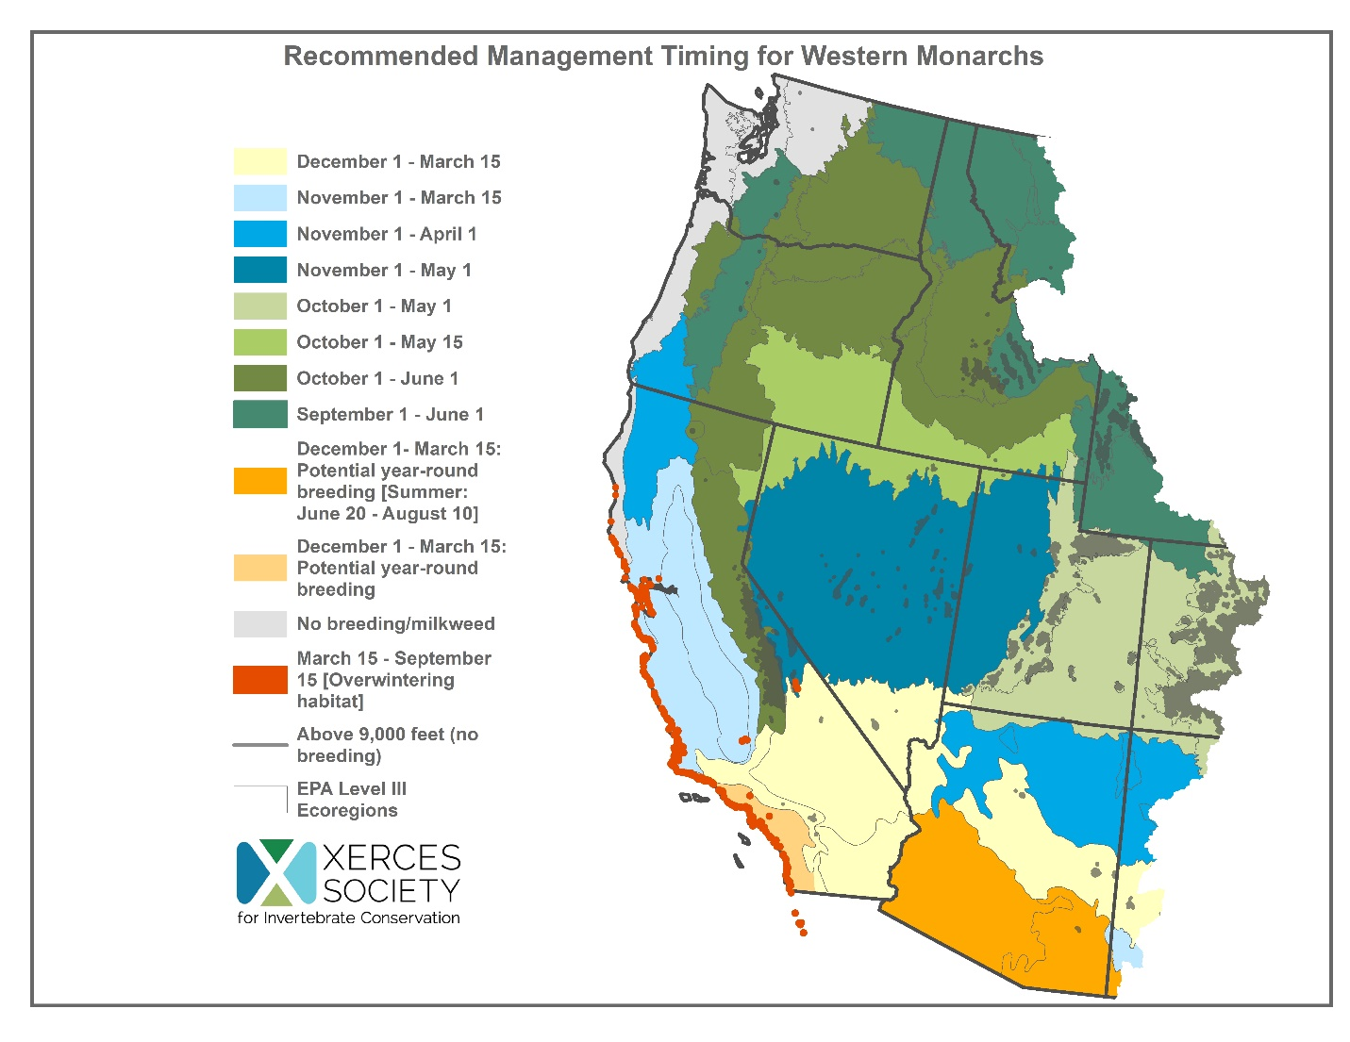Figure 2. Recommended Management (i.e., mowing, burning, grazing, pesticide applications) Timing Windows in the western U.S. by Zone.

Notes: The management timing windows illustrated in Figure 2 represent approximate recommendations of timeframes to conduct management actions. These timeframes are based upon the best available current information and may be updated in the future. Each year and site is different, so when possible, please consider surveying milkweed plants for the early life stages of monarchs prior to burning, mowing, grazing or applying pesticides.

